Compiler Construction Project
Phase II
German Language Compiler
Submitted by: Syed Mohammad Hussain Bukhari
Submitted to: Miss Aneela Mehmood
CFG:
Non-Terminals:
- program
- stml_list
- stmt
- declearation_stmt
- assignment_stmt
- conditional_stmt
- elseif_chain
- optional_else
- loop_stmt
- output_stmt
- expr
Terminals:
- keywords => wenn, sonst, sonst wenn, fur, für, solange, klasse, funktion, drucke, eingabe, gebe, importiere, definiere, wahle, wähle, fall, abbrechen, wahr, falsch
- punctuations => lbrace ({), rbrace (}), lparen ((), rparen ()), colon (:), semicolon (;)
- identifiers/literals => id, string, number
- operators => eq (==), ne (!=), le (<=), ge (>=), plusplus (++), minusminus (--), pluseq (+=), minuseq (-=), timeseq (*=), diveq (/=), plus (+), minus (-), mult (*), div (/), mod (%), assign (=), lt (<), gt (>)
CFG:
Non-Terminal Terminals
- program: stmt_list
- stmt_list: stmt stmt_list | stmt
- stmt: declearation_stmt | conditional_stmt | loop_stmt | output_stmt
- declearation_stmt: FUNKTION ID LPAREN RPAREN LBRACE stmt_list RBRACE
| KLASSE ID LBRACE stmt_list RBRACE
- assignment_stmt: ID ASSIGN expr SEMICOLON | ID PLUSEQ expr SEMICOLON
| ID MINUSEQ expr SEMICOLON | ID TIMESEQ expr SEMICOLON | ID DIVEQ expr SEMICOLON
- conditional_stmt: WENN LPAREN expr RPAREN LBRACE stmt_list RBRACE
elseif_chain optional_else
- elseif_chain: SONSTWENN LPAREN expr RPAREN LBRACE stmt_list
RBRACE elseif_chain | ε
- optional_else: SONST LBRACE stmt_list RBRACE | ε
- loop_stmt: SOLANGE LPAREN expr RPAREN LBRACE stmt_list RBRACE
| FUR LPAREN assignment_stmt expr SEMICOLON assignment_stmt RPAREN LBRACE stmt_list RBRACE
- output_stmt: DRUCKE LPAREN expr RPAREN SEMICOLON
| EINGABE LPAREN ID RPAREN SEMICOLON
- expr: NUMBER | STRING | ID | expr PLUS expr | expr MINUS expr |
expr MULT expr | expr DIV expr | expr MOD expr | expr EQ expr
| expr NE expr | expr GT expr | expr LT expr | LPAREN expr RPAREN

First and Follow set:
Non-terminal | Rules | First | Follow
stmt | declearation_stmt |  conditional_stmt |  loop_stmt |  output_stmt | { FUNKTION, KLASSE, ID, WENN, SOLANGE, FUR, DRUCKE, EINGABE } | { FUNKTION, KLASSE, ID, WENN, SOLANGE, FUR, DRUCKE, EINGABE, RBRACE, $ }
Expr | NUMBER | STRING | ID | expr PLUS expr | expr MINUS expr | expr MULT expr | expr DIV expr | expr MOD expr | expr EQ expr | expr NE expr | expr GT expr | expr LT expr | LPAREN expr RPAREN | { NUMBER, STRING, ID } | { PLUS, MINUS, MULT, DIV, MOD, EQ, NE, LT, GT, RPAREN, SEMICOLON }

Test Program:
funktion myFunc() {
x = 10;
y = 20;
wenn (x < y) {
drucke(x);
} sonst {
drucke(y);
}
solange (x < 15) {
x = x + 1;
}
}

Parse Tree:
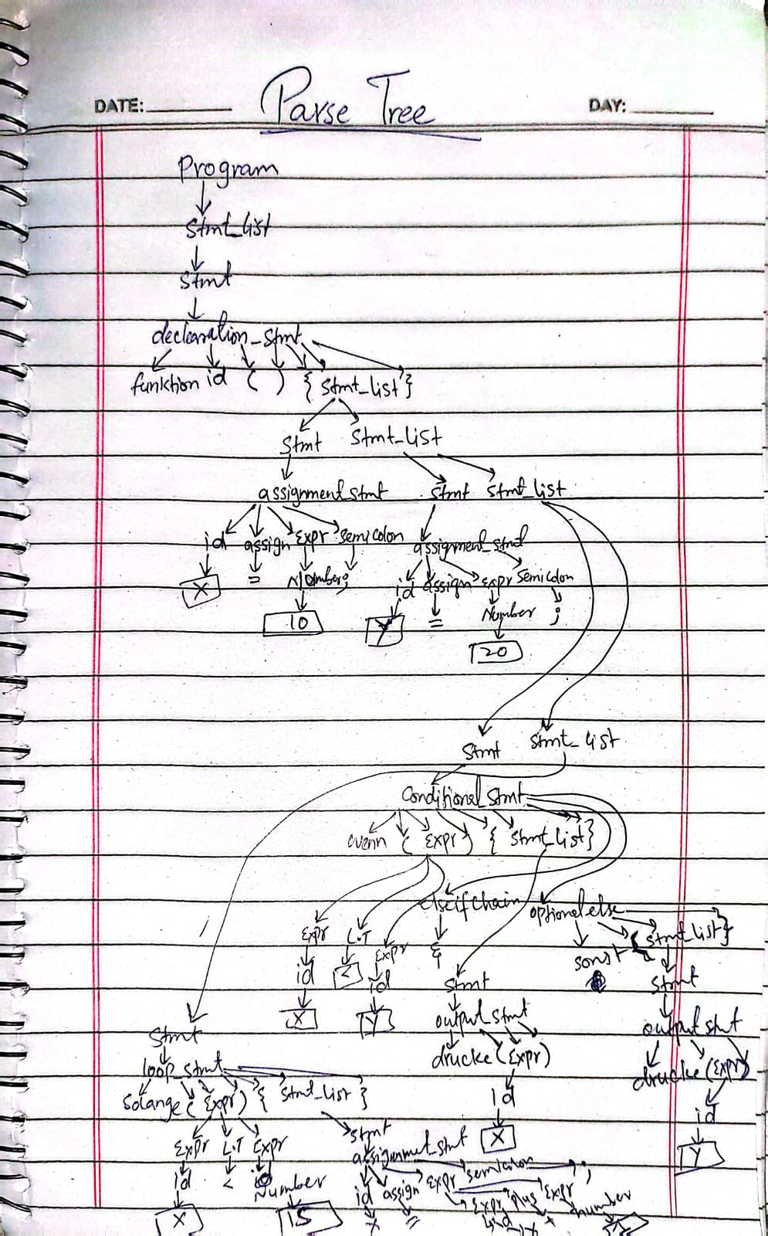
Explanation of Phase 1 tokens usage
- Tokens like ID, NUMBER, STRING, WENN, SONST, FUR, etc. are directly reused from Phase 1 scanner.
- Scanner.l file from phase 1 is modified because initially it was just printing tokens but it is also returning tokens too,
- All operators and punctuations (+, -, =, {, }) are used exactly as in Phase 1.
- Parser does not redefine any tokens, ensuring Phase 1 and Phase 2 are consistent.
Code and Screenshots:
Scanner.l
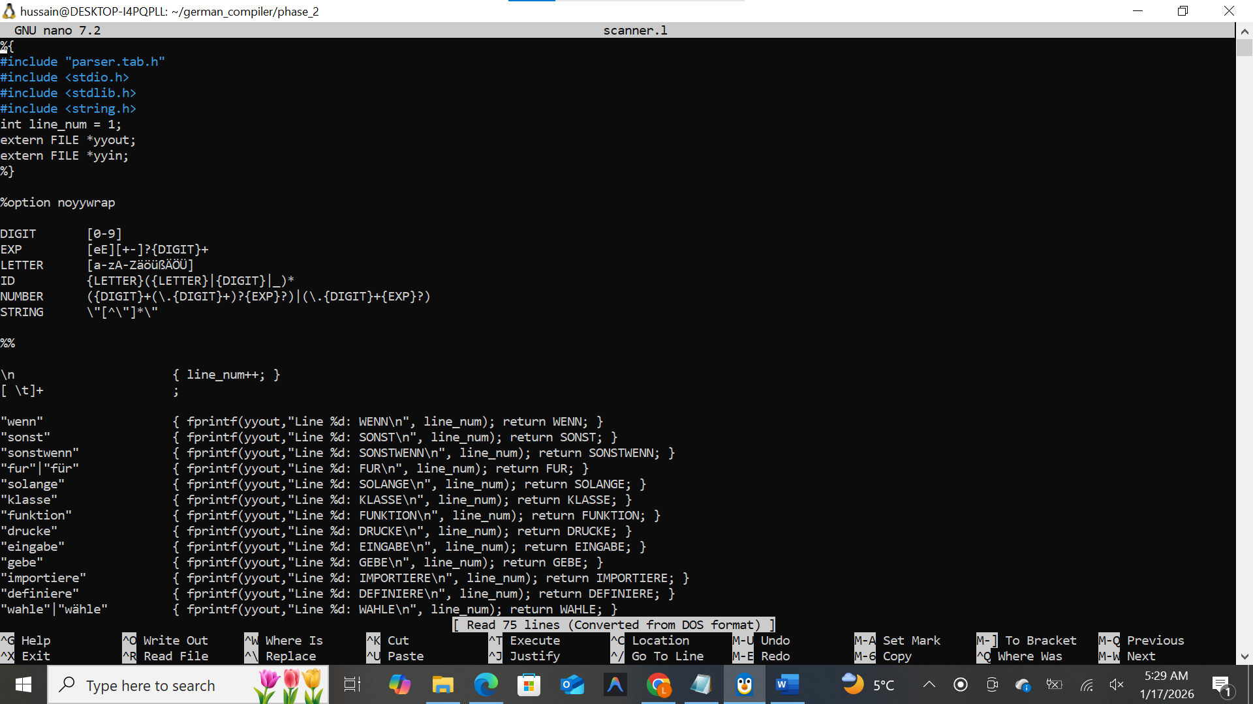
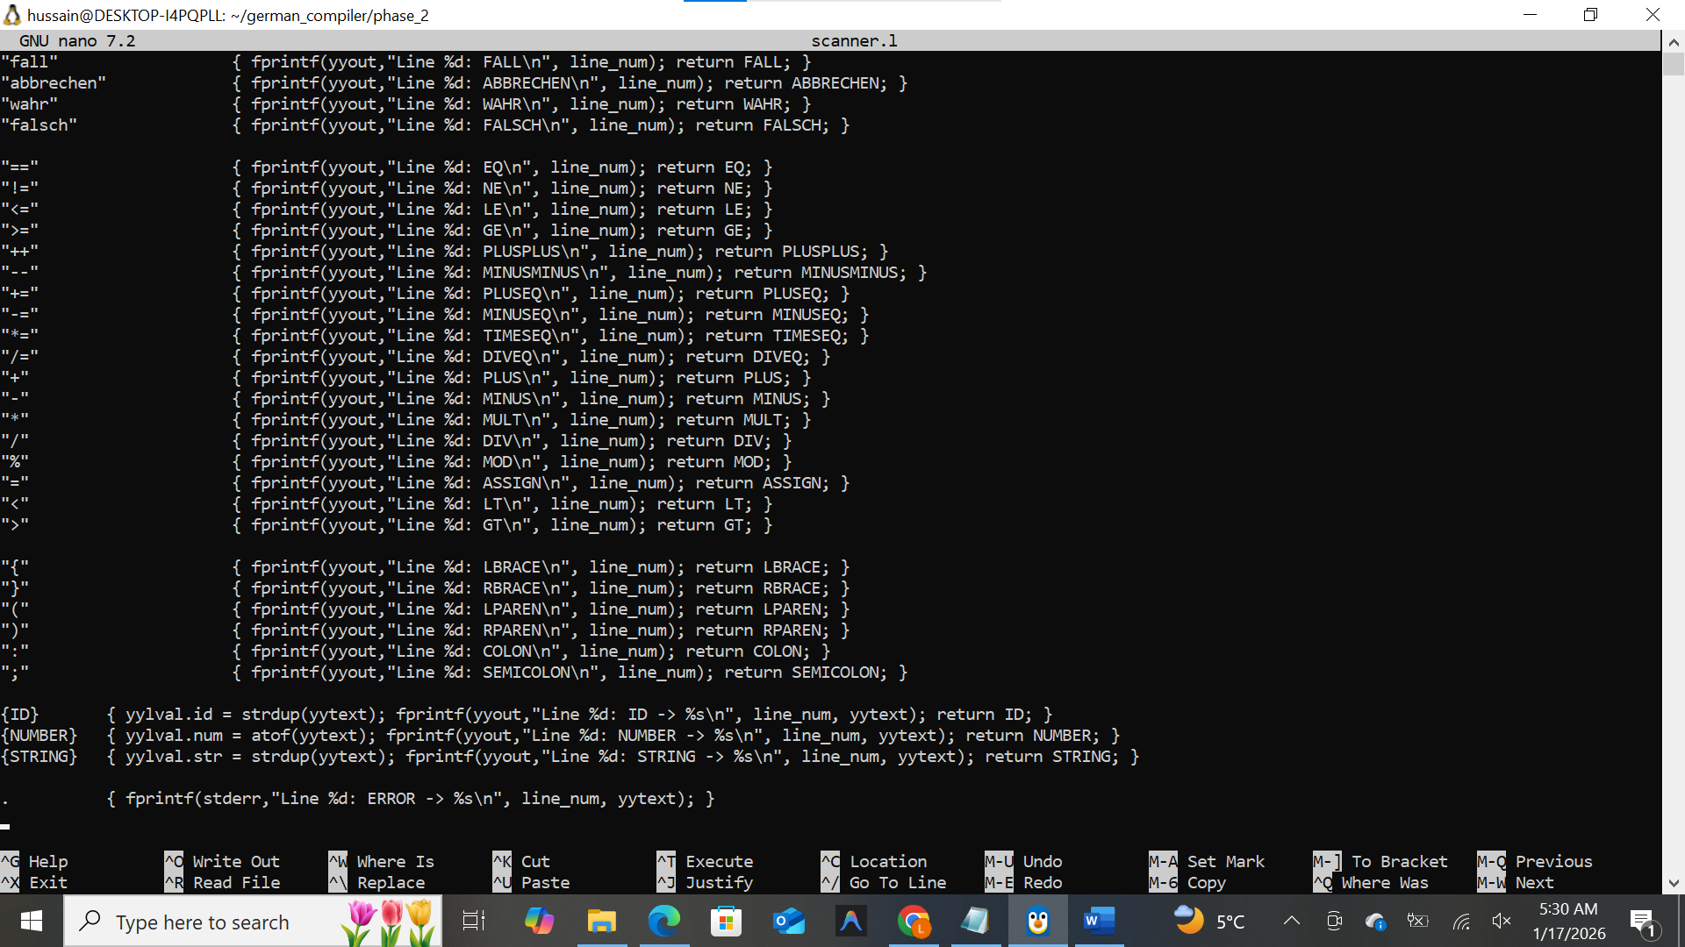

Parser.y
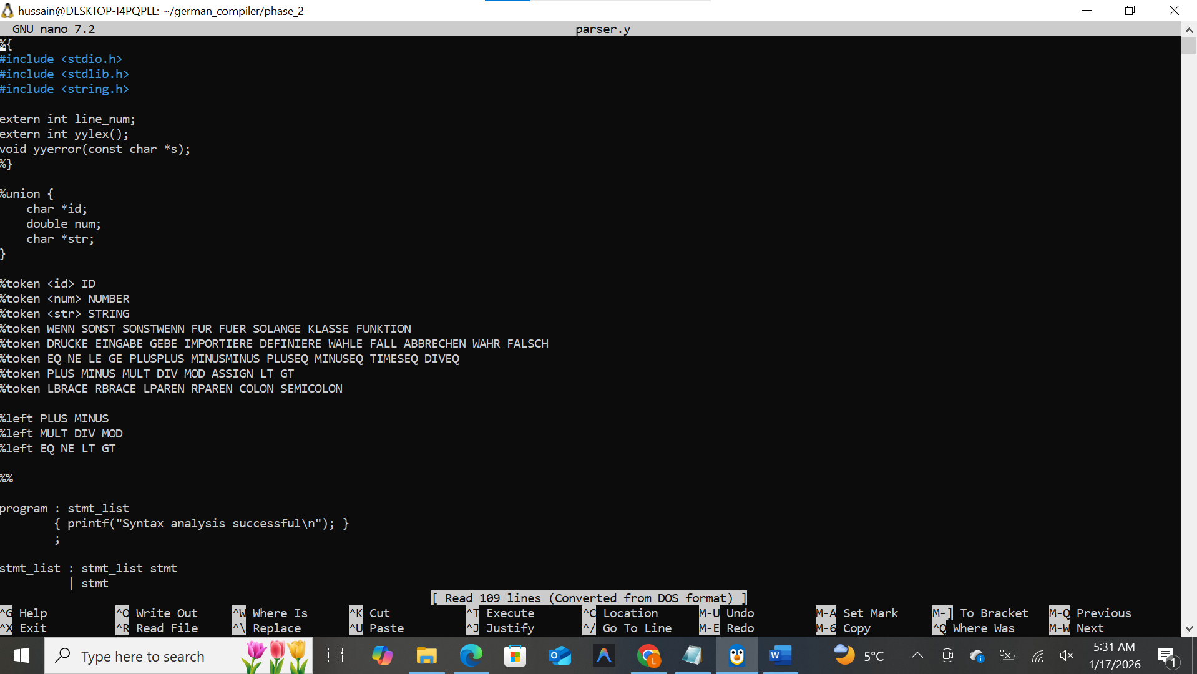
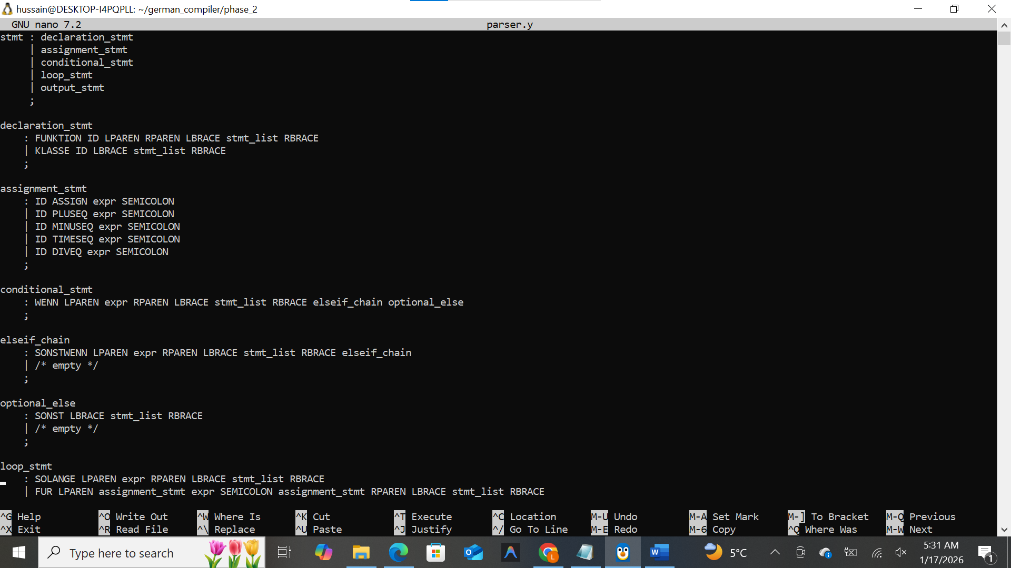
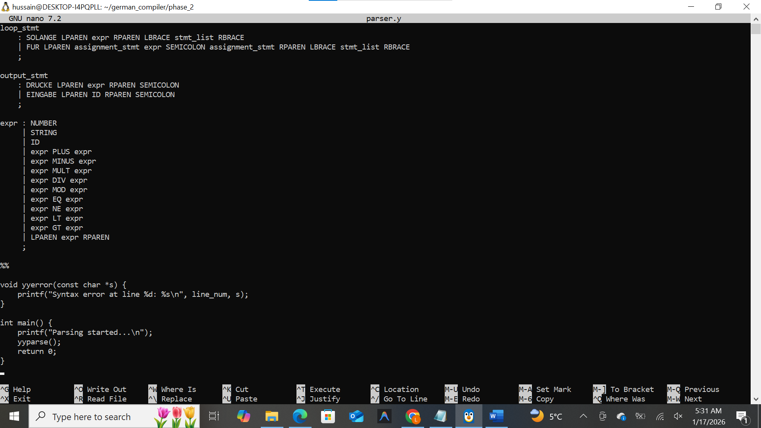

Valid Program tokens:
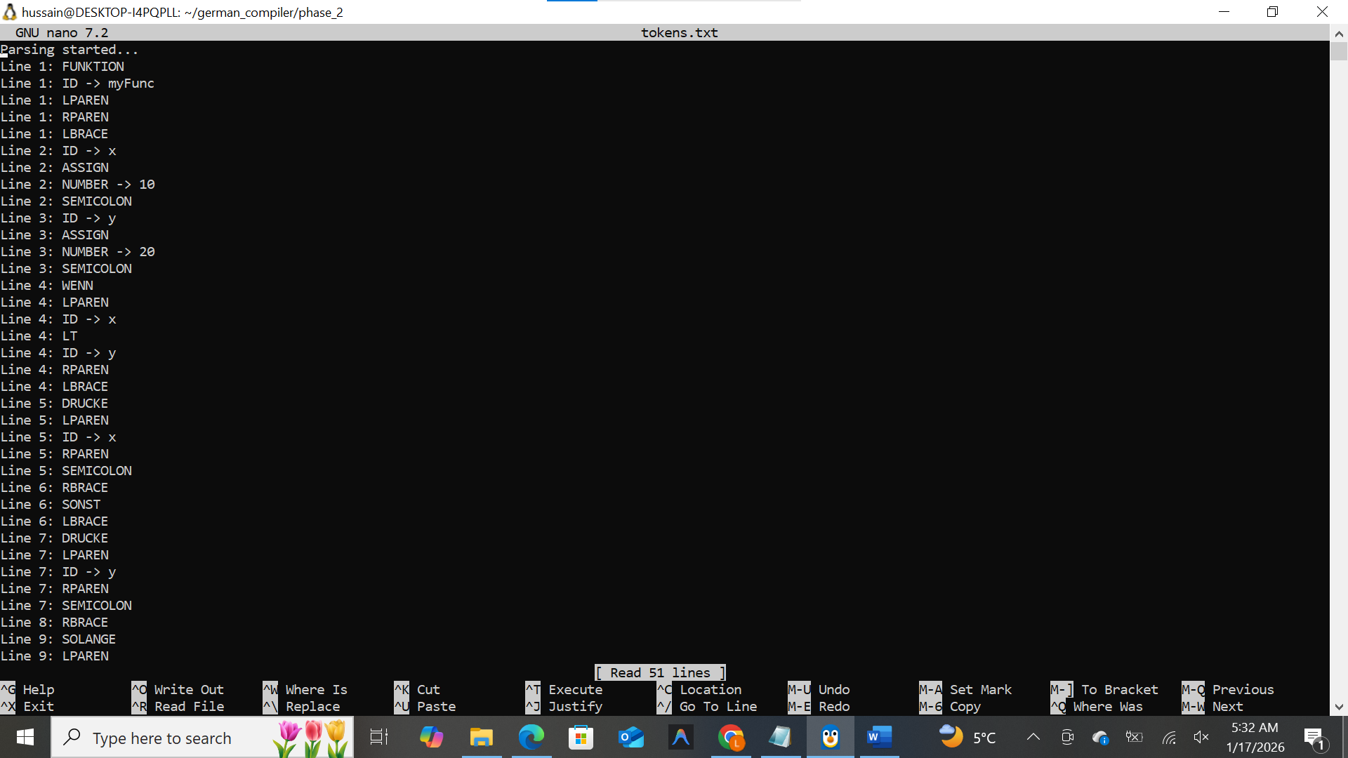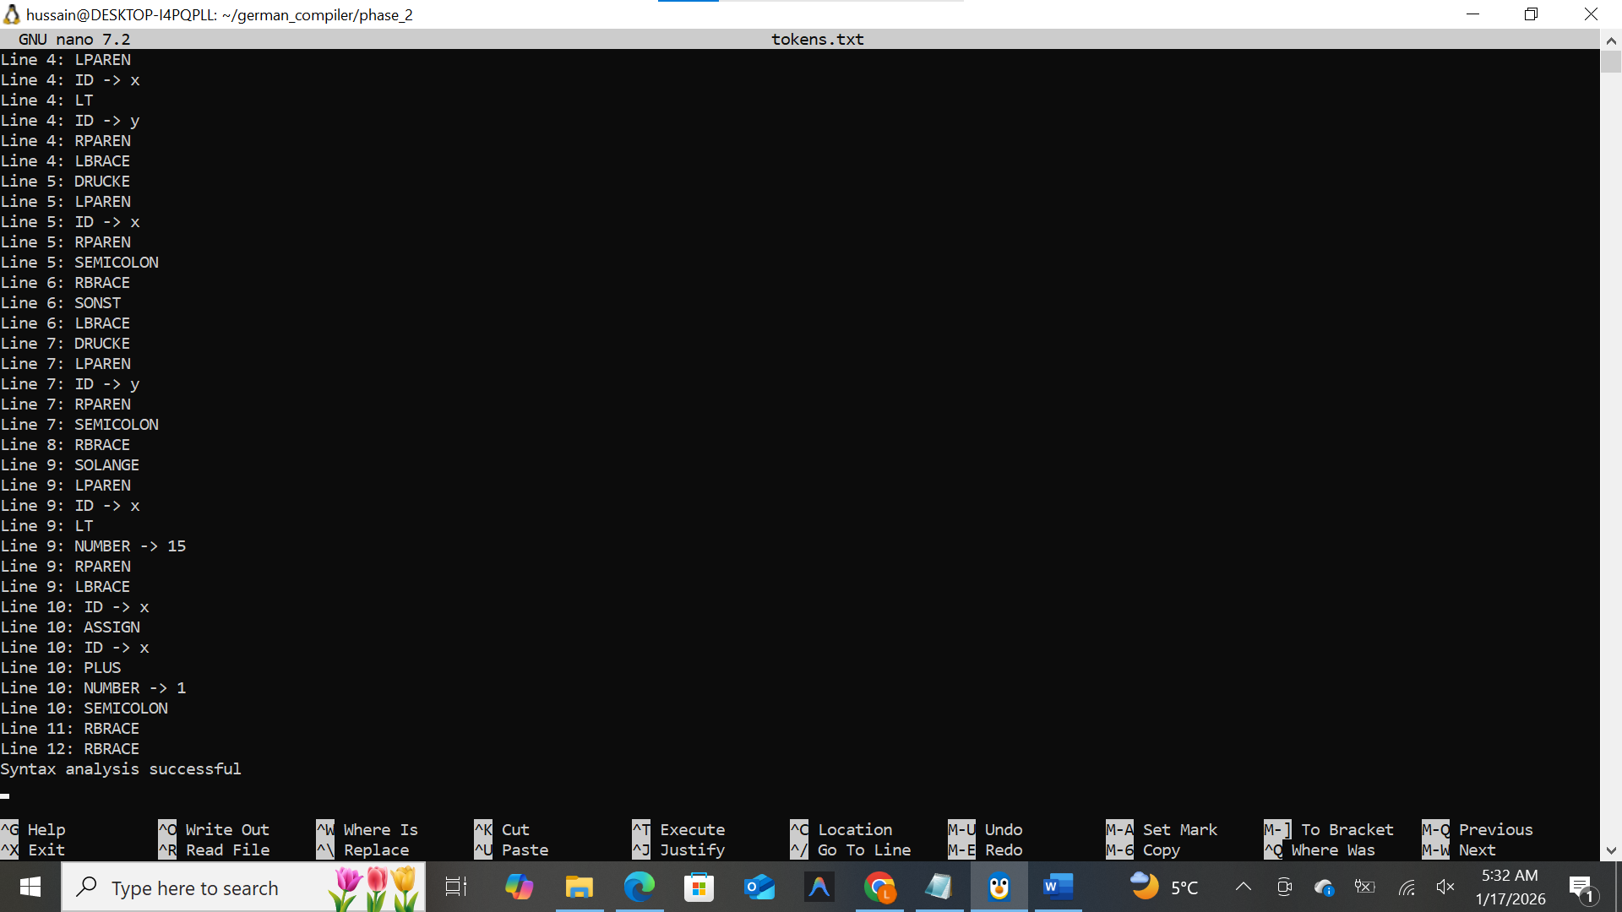

Invalid Program tokens:
